26 댓글 수정 with JS

**댓글 수정 with 자바스크립트**

**미션**

댓글 수정 페이지를 만들고, REST API를 호출하여 댓글을 수정하시오.  
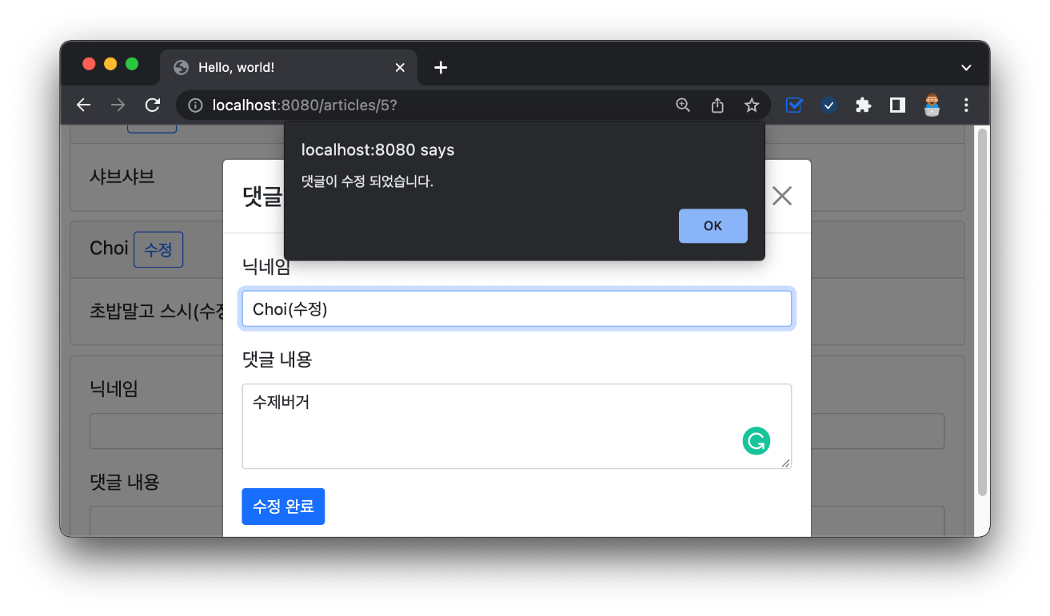

**01:31 수정 버튼 추가 - 부트스트랩, modal trigger button**

../comments/_list.mustache

1. <div id="comments-list">
2. {{#commentDtos}}
3. <div class="card m-2" id="comments-{{id}}">
4. <div class="card-header">
5. {{nickname}}
6. <!-- 수정 버튼 추가 -->
7. <button class="btn btn-sm btn-outline-primary">수정</button>
8. </div>
9. <div class="card-body">
10. {{body}}
11. </div>
12. </div>
13. {{/commentDtos}}
14. </div>

**02:27 부트스트랩5 모달 - bootstrap, modal**

../comments/_list.mustache

1. <div id="comments-list">
2. {{#commentDtos}}
3. <div class="card m-2" id="comments-{{id}}">
4. <div class="card-header">
5. {{nickname}}
6. <!-- Button trigger modal -->
7. <button type="button"
8. class="btn btn-sm btn-outline-primary"
9. data-bs-toggle="modal"
10. data-bs-target="#comment-edit-modal">수정</button>
11. </div>
12. <div class="card-body">
13. {{body}}
14. </div>
15. </div>
16. {{/commentDtos}}
17. </div>
18. <!-- Modal -->
19. <div class="modal fade" id="comment-edit-modal" tabindex="-1">
20. <div class="modal-dialog">
21. <div class="modal-content">
22. <div class="modal-header">
23. <h5 class="modal-title" id="exampleModalLabel">댓글 수정</h5>
24. <button type="button" class="btn-close" data-bs-dismiss="modal" aria-label="Close"></button>
25. </div>
26. <div class="modal-body">
27. ...
28. </div>
29. </div>
30. </div>
31. </div>

**05:25 수정 폼 삽입 - bootstrap, form, hidden input**

../comments/_list.mustache

1. <div id="comments-list">
2. {{#commentDtos}}
3. ...
4. {{/commentDtos}}
5. </div>
6. <!-- Modal -->
7. <div class="modal fade" id="comment-edit-modal" tabindex="-1">
8. ...
9. <div class="modal-body">
10. <!-- 댓글 수정 폼 추가 -->
11. <form>
12. <!-- 닉네임 -->
13. <div class="mb-3">
14. <label class="form-label">닉네임</label>
15. <input type="text" class="form-control form-control-sm" id="edit-comment-nickname">
16. </div>
17. <!-- 댓글 본문 -->
18. <div class="mb-3">
19. <label class="form-label">댓글 내용</label>
20. <textarea type="text" class="form-control form-control-sm" rows="3" id="edit-comment-body"></textarea>
21. </div>
22. <!-- 히든값 -->
23. <input type="hidden" id="edit-comment-id">
24. <input type="hidden" id="edit-comment-article-id">
25. <!-- 전송버튼 -->
26. <button type="button" class="btn btn-outline-primary btn-sm" id="comment-update-btn">수정 완료</button>
27. </form>
28. </div>
29. ...
30. </div>

**07:10 트리거 데이터 전달 - button attribute, data-bs-\***

../comments/_list.mustache

1. <div id="comments-list">
2. {{#commentDtos}}
3. <div class="card m-2" id="comments-{{id}}">
4. <div class="card-header">
5. {{nickname}}
6. <!-- Button trigger modal -->
7. <button type="button"
8. class="btn btn-sm btn-outline-primary"
9. data-bs-toggle="modal"
10. data-bs-target="#comment-edit-modal"
11. data-bs-id="{{id}}"
12. data-bs-nickname="{{nickname}}"
13. data-bs-body="{{body}}"
14. data-bs-article-id="{{articleId}}">수정</button>
15. </div>
16. <div class="card-body">
17. {{body}}
18. </div>
19. </div>
20. {{/commentDtos}}
21. </div>
22. <!-- Modal -->
23. <div class="modal fade" id="comment-edit-modal" tabindex="-1">
24. <div class="modal-dialog">
25. <div class="modal-content">
26. <div class="modal-header">
27. <h5 class="modal-title" id="exampleModalLabel">댓글 수정</h5>
28. <button type="button" class="btn-close" data-bs-dismiss="modal" aria-label="Close"></button>
29. </div>
30. <div class="modal-body">
31. <!-- 댓글 수정 폼-->
32. <form>
33. <!-- 닉네임 입력 -->
34. <div class="mb-3">
35. <label class="form-label">닉네임</label>
36. <input type="text" class="form-control form-control-sm" id="edit-comment-nickname">
37. </div>
38. <!-- 댓글 본문 입력 -->
39. <div class="mb-3">
40. <label class="form-label">댓글 내용</label>
41. <textarea type="text" class="form-control form-control-sm" rows="3" id="edit-comment-body"></textarea>
42. </div>
43. <!-- 히든 인풋 -->
44. <input type="hidden" id="edit-comment-id">
45. <input type="hidden" id="edit-comment-article-id">
46. <!-- 전송 버튼 -->
47. <button type="button" class="btn btn-outline-primary btn-sm" id="comment-update-btn">수정 완료</button>
48. </form>
49. </div>
50. </div>
51. </div>
52. </div>
53. <!-- 모달 이벤트 처리 -->
54. <Script>
55. {
56. // 모달 요소 선택
57. const commentEditModal = document.querySelector("#comment-edit-modal");
58. // 모달 이벤트 감지
59. commentEditModal.addEventListener("show.bs.modal", function(event) {
60. // 트리거 버튼 선택
61. const triggerBtn = event.relatedTarget;
62. // 데이터 가져오기
63. const id = triggerBtn.getAttribute("data-bs-id");
64. const nickname = triggerBtn.getAttribute("data-bs-nickname");
65. const body = triggerBtn.getAttribute("data-bs-body");
66. const articleId = triggerBtn.getAttribute("data-bs-article-id");
67. //console.log(`${id}, ${nickname}, ${body}, ${articleId}`);
68. // 데이터를 반영
69. document.querySelector("#edit-comment-nickname").value = nickname;
70. document.querySelector("#edit-comment-body").value = body;
71. document.querySelector("#edit-comment-id").value = id;
72. document.querySelector("#edit-comment-article-id").value = articleId;
73. });
74. }
75. </script>

**17:14 REST API 호출로 수정 - querySelector(), addEventListener(), fetch()**

../comments/_list.mustache

1. <div id="comments-list">
2. {{#commentDtos}}
3. ...
4. {{/commentDtos}}
5. </div>
6. <!-- Modal -->
7. <div class="modal fade" id="comment-edit-modal" tabindex="-1">
8. ...
9. </div>
10. <!-- 모달 이벤트 처리 -->
11. <Script>
12. {
13. ...
14. }
15. {
16. // 수정 완료 버튼
17. const commentUpdateBtn = document.querySelector("#comment-update-btn");
18. // 클릭 이벤트 처리
19. commentUpdateBtn.addEventListener("click", function() {
20. // 수정 댓글 객체 생성
21. const comment = {
22. id: document.querySelector("#edit-comment-id").value,
23. nickname: document.querySelector("#edit-comment-nickname").value,
24. body: document.querySelector("#edit-comment-body").value,
25. article_id: document.querySelector("#edit-comment-article-id").value
26. };
27. console.log(comment);
28. // 수정 REST API 호출 - fetch()
29. const url = "/api/comments/" + comment.id;
30. fetch(url, {
31. method: "PATCH",
32. body: JSON.stringify(comment),
33. headers: {
34. "Content-Type": "application/json"
35. }
36. }).then(response => {
37. // http 응답 코드에 따른 메시지 출력
38. const msg = (response.ok) ? "댓글이 수정 되었습니다." : "댓글 수정 실패..!";
39. alert(msg);
40. // 현재 페이지를 새로고침
41. window.location.reload();
42. });
43. });
44. }
45. </script>

**🔥 구글링 훈련하기**

* 부트스트랩5 모달